Activity 16 PostgreSQL

Tarandeep singh

A INSERT INTO artist

(id,name)

VALUES

(3,'taran')

;

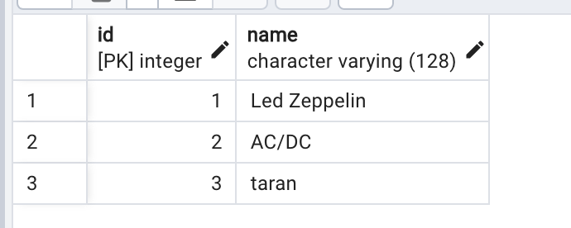

B

INSERT INTO album

(id,title,artist_id)

VALUES

(3,' NOVEMBER RAIN', 3)

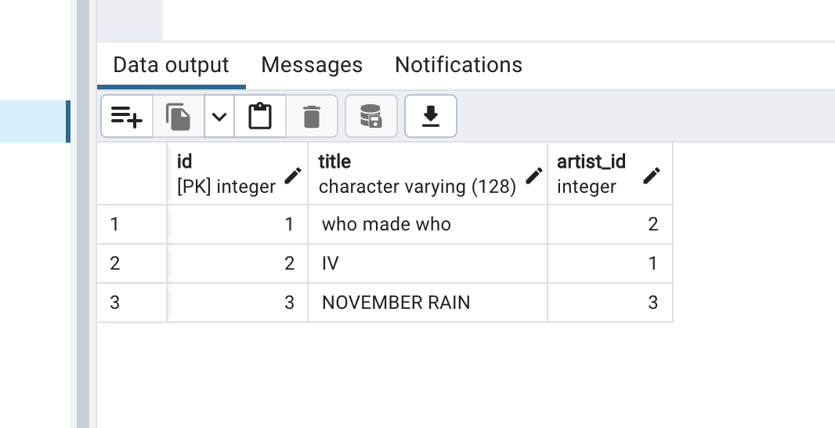

C

SELECT album.title, artist.name, artist.id FROM album Join artist on album.artist_id = artist.id;

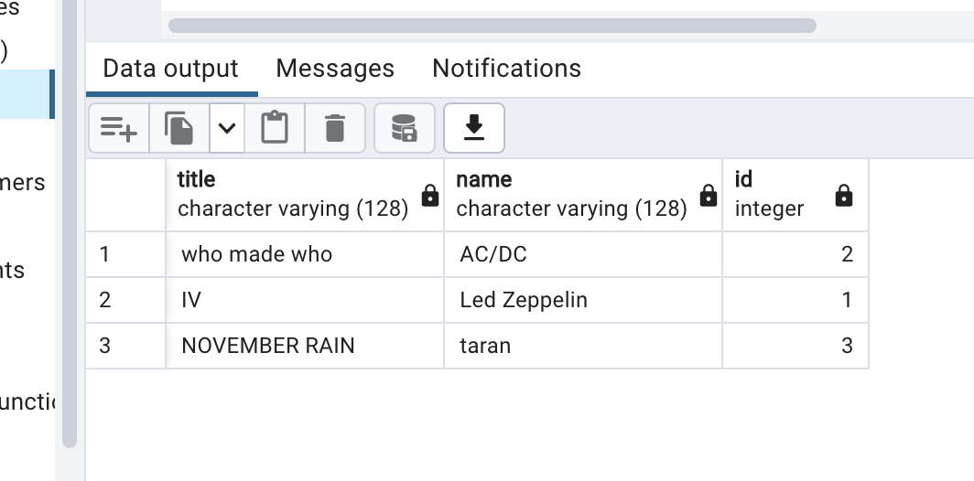

D SELECT track.title, genre.name FROM track JOIN genre ON track.album_id = genre.id;

